Programming Assignment

Lesson 4

CISC 071

By

Jeremy Reuwer

Date: 2/22/2019

Purpose

* To learn about arithmetic operations

Rubric

* Correctness: 2 Points. Program should work as specified
* Input/Output: 2 Points. Show the inputs and outputs to the program. If Applicable multiple examples needed
* Coding style/Comments: 1 Points.

Project Assignment

* Use the setup function to set the serial monitor and print “Serial monitor setup done”
* Write code in the setup function to convert temperature value from Fahrenheit to Celsius.
* Set Fahrenheit Temperature to 92 degrees and print it
* Compute the Celsius value and print it.
* Leave the loop function empty, since we only want to do the above calculations once

Learning Notes:

The Arduino can do mathematics for us. In this part of the course, we look at how to do addition, subtraction, multiplication, division, and find a remainder. Below, five arithmetic operators are described.

**Addition**

To add numbers on the Arduino, we use the addition operator (+).

The example below shows how to add two numbers together.

*int a = 2;*

*int b = 7;*

*int sum;*

*sum = a + b;*

In the above code, three variables are defined. Variables a and b are each assigned a value when they are defined. The sum variable is defined, but not initialized, so contains any random number. We will use this variable to store the result of the addition calculation, so the random value that sum contains will be overwritten when we put the addition result (or sum) into it.

After the statement shown below has been executed, sum will contain the value 9 i.e. the result of the addition of variable a and b.

*sum = a + b;*

We can also add two constant values and store the result in a variable as shown below.

*int sum;*

*sum = 2 + 10;*

The result stored in sum after execution of the addition statement will be 12 in this example.

Constant values and variables can also be added together and the result stored in a variable as shown here.

*int a = 3;*

*int sum;*

*sum = a + 24;*

After execution of the addition, sum will contain 27.

The remaining arithmetic operators can also operate on constant values, variables and a mixture of both.

**Subtraction**

The subtraction operator subtracts one number from another using the minus sign (-) as the following example shows.

*int result;*

*result = 10 - 2;*

The result of this calculation will be 8 and will be stored in the result variable.

**Multiplication**

Multiplication is done by using the multiplication operator (*).

*int result;*

*result = 4 * 3;*

The result of the above calculation will be 12 and will be stored in the result variable.

**Division**

The division operator (/) is used to perform division in the Arduino.

*int result;*

*result = 12 / 3;*

The result of the above calculation is 4.

**Integers vs. Floating Point**

So far we have only been using integer values to perform arithmetic. If the result of a division is not an integer (or whole number), but contains a fraction part, the fraction part will be discarded if the result is stored in an integer variable.

The following examples will demonstrate what happens when a result with a fractional part is stored in an integer and then a floating point variable.

*int result;*

*result = 5 / 4;*

The result will be 1 because the fraction is discarded when the result is stored in the integer variable result.

The same calculation, but this time defining result as a floating point variable (float).

*float result;*

*result = 5.0 / 4.0;*

The result now contained in the result variable is 1.25.

When using constant values in calculations that store the result in a floating point variable, we use a decimal point and a zero for whole numbers, i.e. 5.0 instead of 5 on its own.

**Remainder (Modulo Division)**

The remainder operator (or modulo operator) is used to find the remainder after the division of two numbers. The percentage sign (%) is used as the modulo operator.

*int result;*

*result = 11 % 4;*

The result of this calculation will be the remainder of 11 divided by 4 which is 3 (4 goes into 11 twice leaving a remainder of 3).

**print() Function**

print() is called when the invisible cursor must stay on the same line so text following it will also be printed on the same line as well.

**println() Function**

println() is used when text must be printed and then the invisible cursor moved to the next line so that the next print() statement will print text on a new line.

**Constants and Variables**

Constants are numbers that remain constant throughout a sketch – i.e. they never change.

Examples of constants are the numbers that are used directly in a calculation and are not assigned to a variable, e.g. sum = 2 + 3 contains the constants 2 and 3.

Constants do not have a name and their values can not be changed when the sketch is running.

**For further details refer to the Arduino programming reference guide**

<https://playground.arduino.cc/uploads/Main/arduino_notebook_v1-1.pdf>

Program

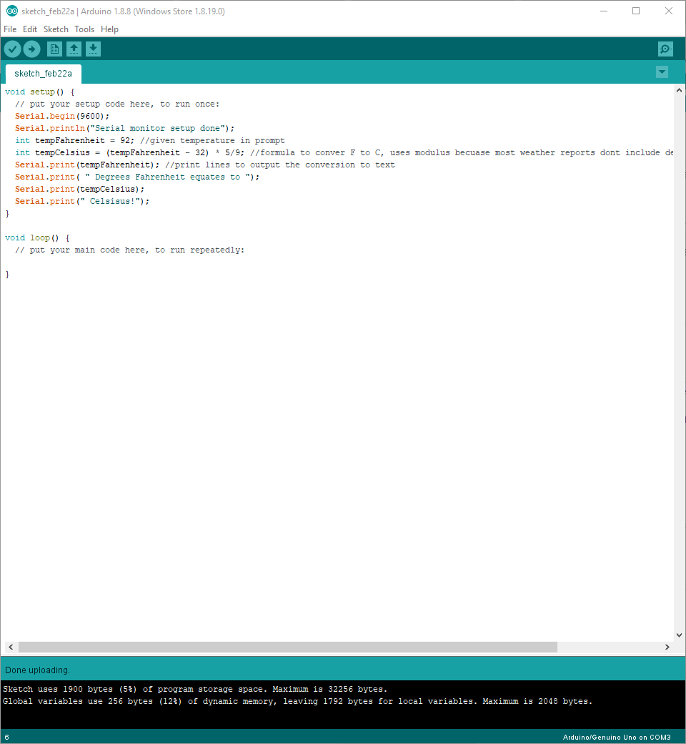

Inputs/Outputs

